AI ASSISTANT CODING
ASSIGNMENT – 5.1
Name : M.Vyshnavi
Hall Ticket no: 2303A54068
Batch : 48
1. Task Description #1 (Privacy in API Usage)
Prompt:

Code:
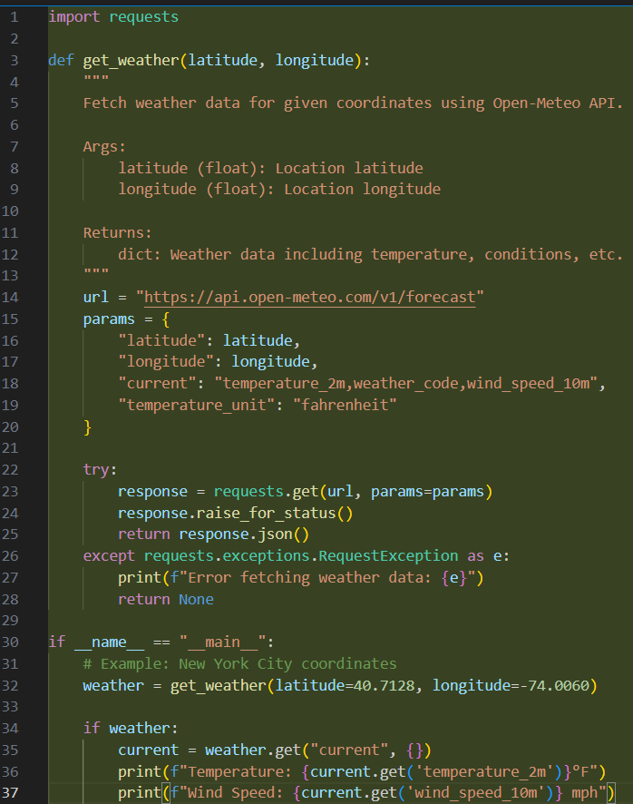
This AI generated code doesn’t expose any API keys. It doesn’t require any credentials. But usually, the code which is given by AI exposes API keys and they also require authentication. So storing the API keys is very important to prevent any misuse.
2. Task Description #2 (Privacy & Security in File Handling)
Prompt:
Code:
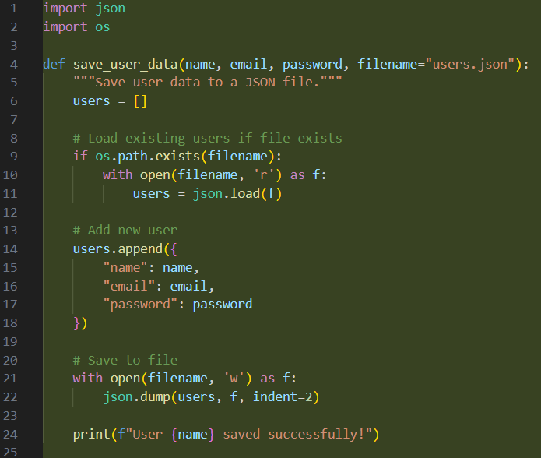
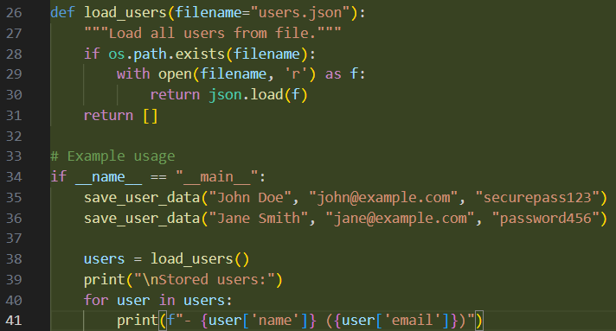
In this generated code, the passwords are in plain text, no encryption or hashing is used and also if the file is leaked all the user passwords will be leaked. This results in privacy and security risks.
Re-generated code:
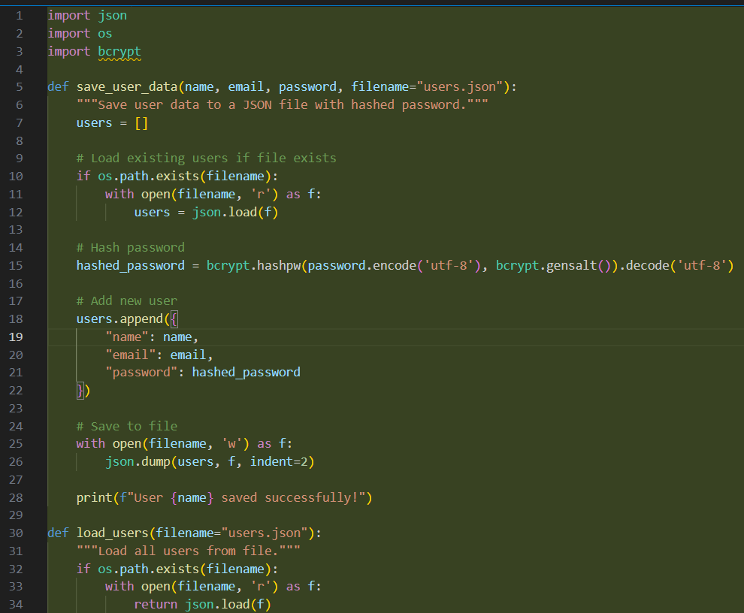
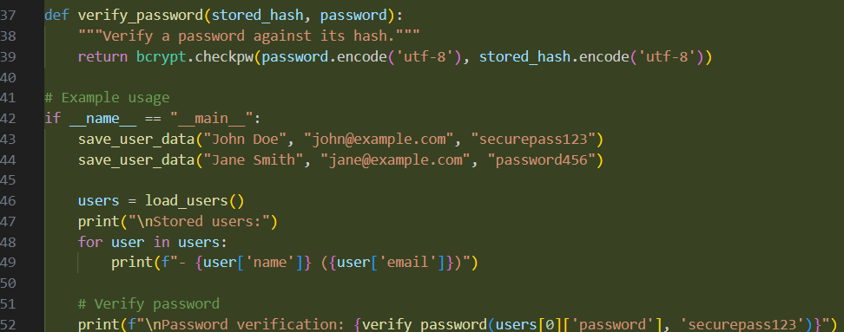
3. Task Description #3 (Transparency in Algorithm Design)
Prompt:
Code:
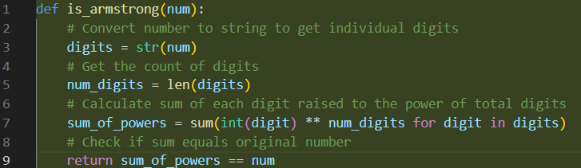
Explanation:
- First the number is converted into a string so that we can retrieve each digit easily.
- Now, it counts the number of digits and stores it in “num_digits”.
- It’ll now convert each digit into integer, and each digit is raised to the power of total digits.
- The calculated sum is compared to the original digit.
4. Task Description #4 (Transparency in Algorithm Comparison)
Prompt:

Code:
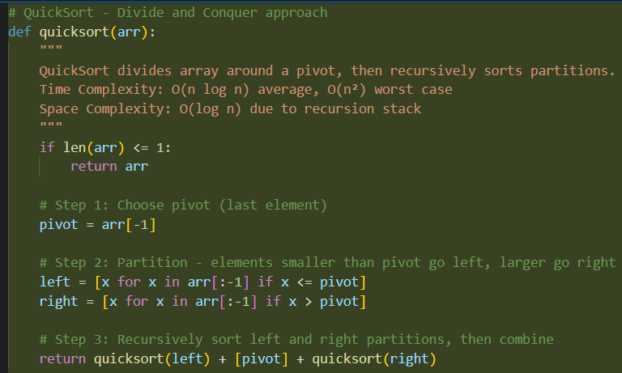
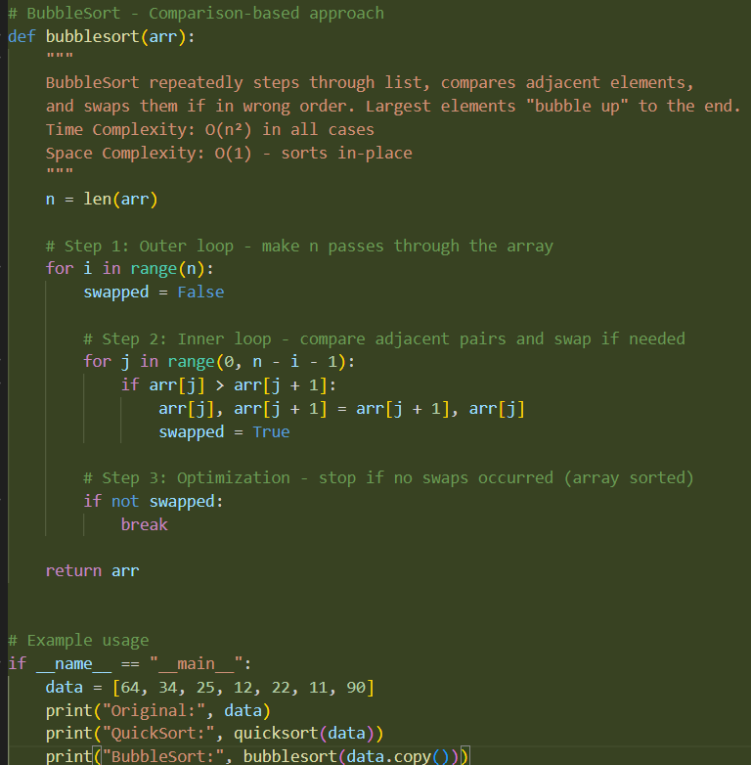
Output:
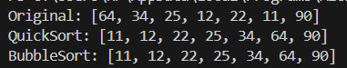
5. Task Description #5 (Transparency in AI Recommendations)
Prompt:
Code:
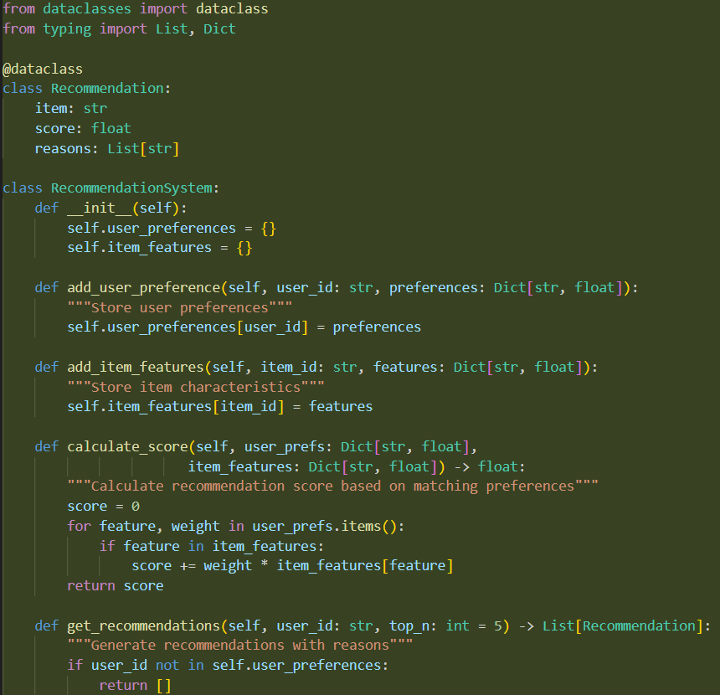
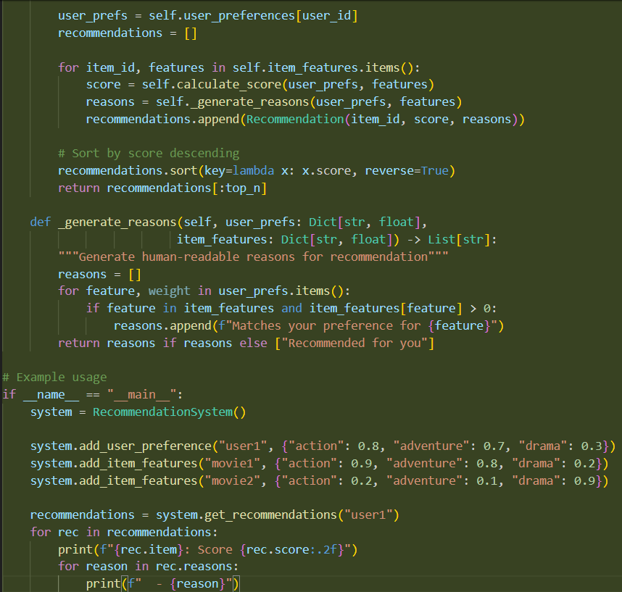
Output:
